Project File

BIG BAZZAR

BILL GENERATING SYSTEM



Contents

* Certificate
* Acknowledgement
* Project Name
* Programs
* Coding
* SQL tables
* Bibliography

Programs

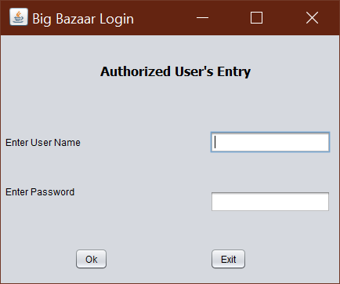

Input Password

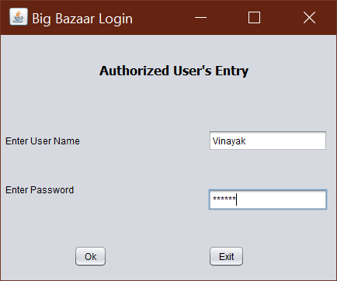

If password or username match it will move on to the next frame & if it does not it will show the following error

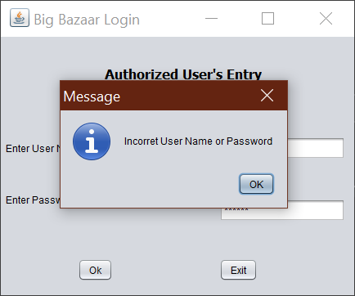

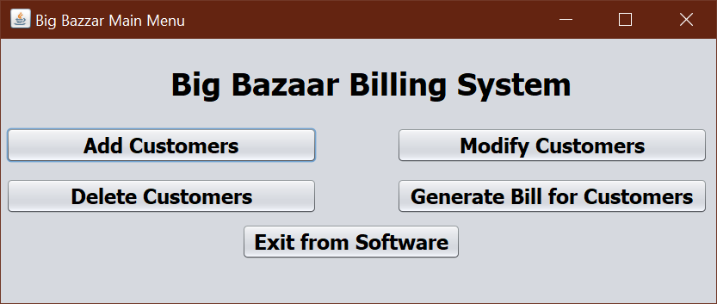Next comes the main menu, here you can do different tasks.

On clicking the button Add Customers, Name and details of the customer will be added in customer record.

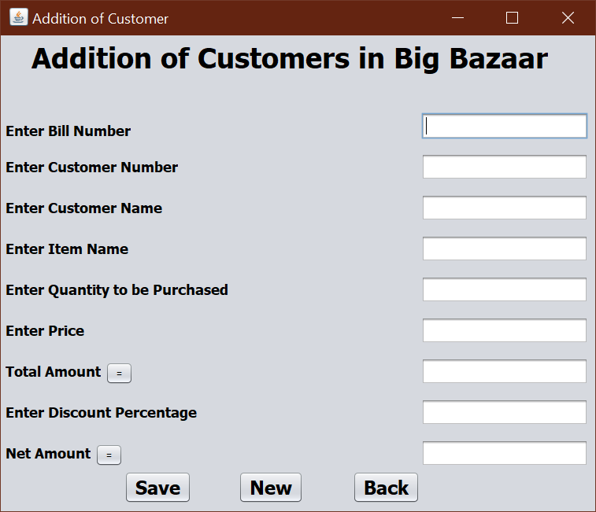

On clicking the Save button the whole record of the customer will be added in the list.

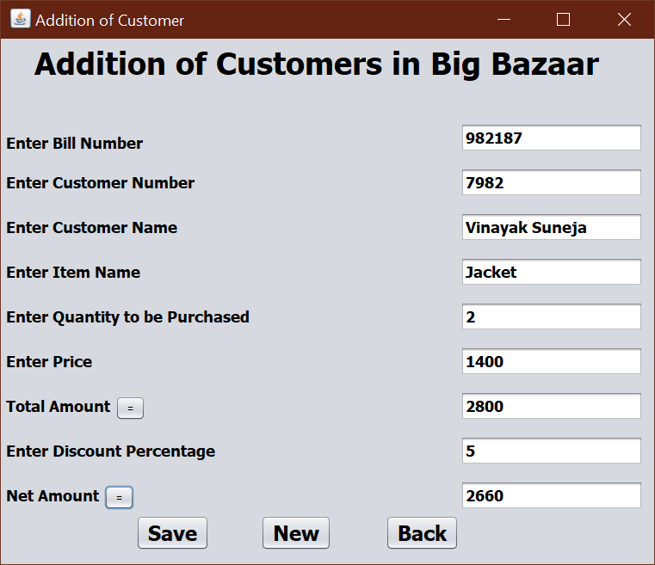

On clicking on the New button

On clicking on the Back button, the Main Menu will appear.

On clicking on the Modify Customers, it updates the changes made in the customer’s record.

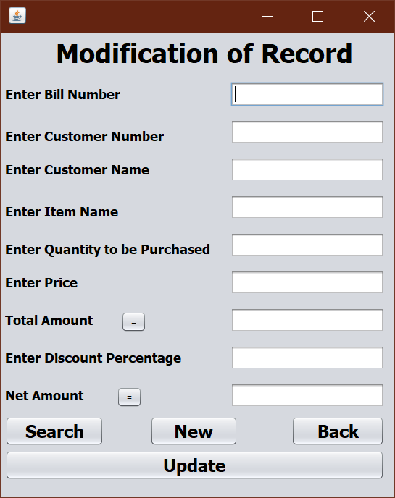

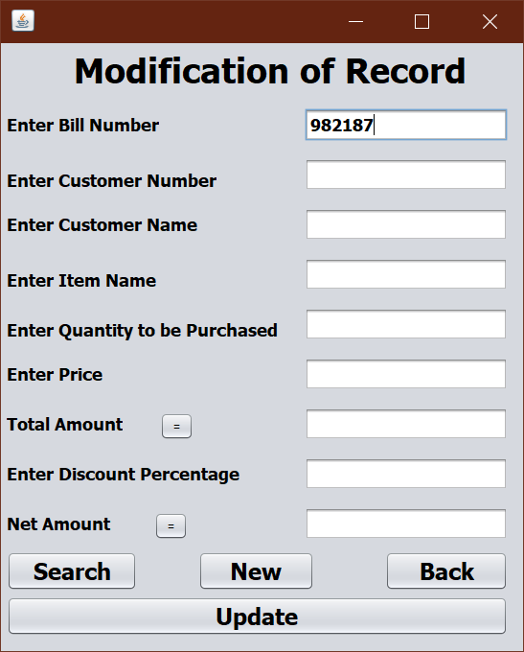Search button will search and display the customer’s details.

On clicking on the search button

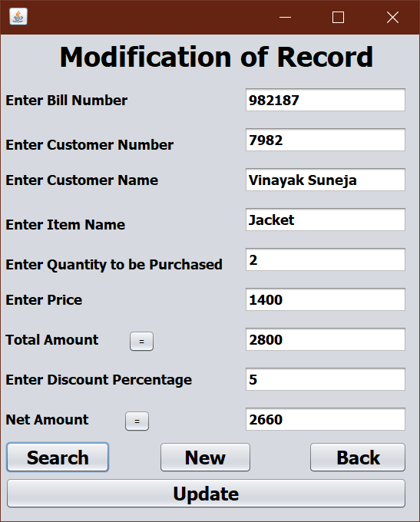

New will make all the text boxes empty for the new action.

Update will modify the latest change made in customer record.

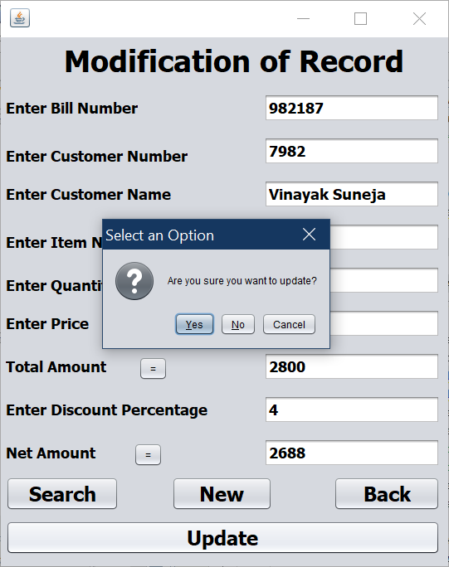

Back will take us to the Main Menu.



On clicking on the Delete Customer button.

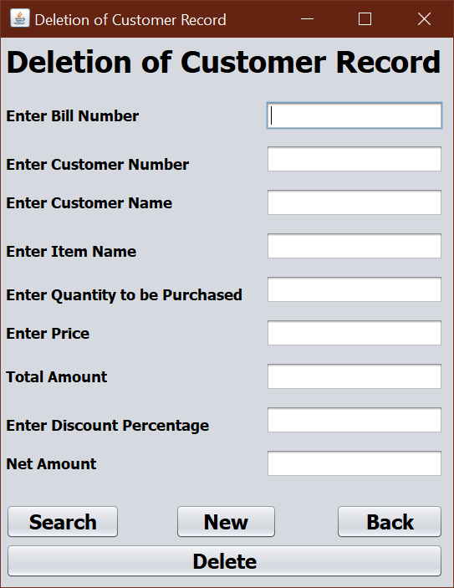

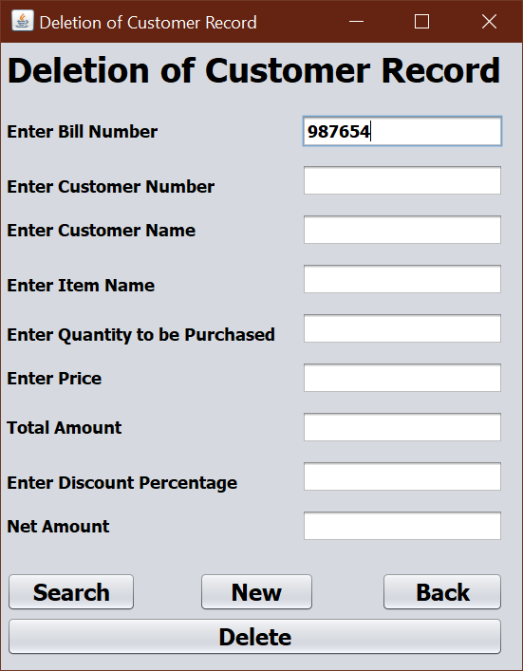Search will provide the details about the customer.

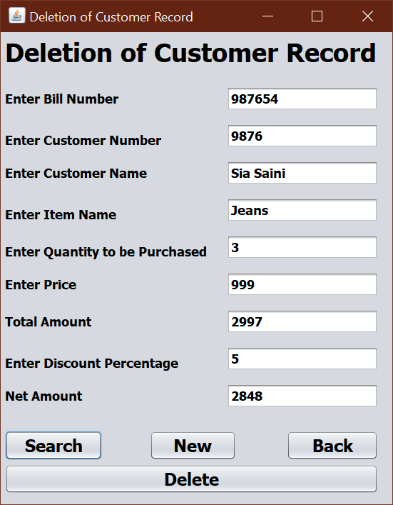

New will make all the text boxes empty.



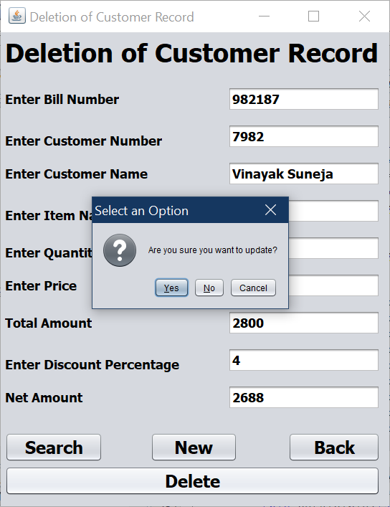Delete will delete the record of present customer from the records.

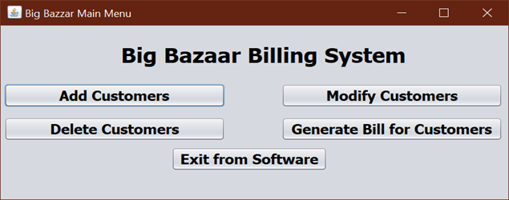Back will take us to the Main Menu.

Clicking on the Generate Bill will take us to the bill creation window.

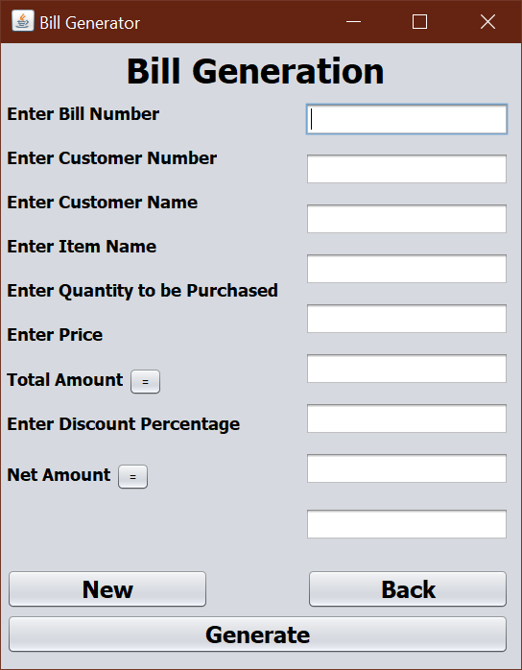

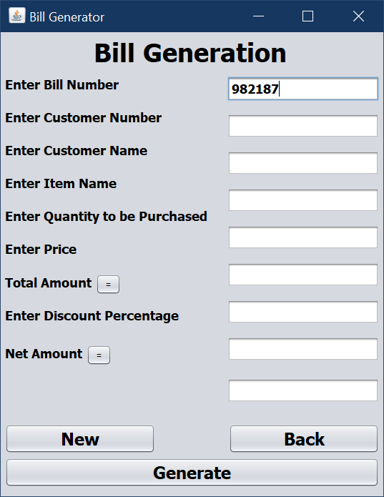Generate button generates the bill on the bases of Bill no.

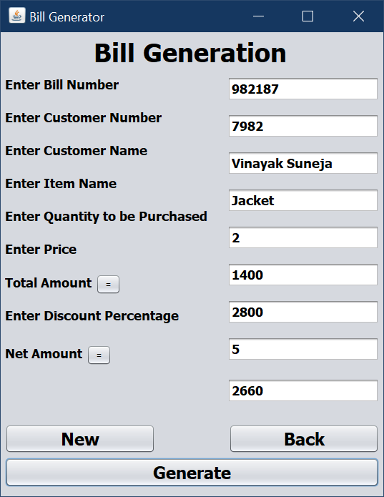

New will make all the text boxes empty for new transaction.

Back will take us to the Main Menu

Exit from software will close the software.

Coding

For command button Ok

String User,Pass;

User = jTextField1.getText();

Pass = jPasswordField1.getText();

Connection con=null;

Statement stmt=null;

ResultSet rs=null;

try{

Class.forName("java.sql.Driver");

con = DriverManager.getConnection("jdbc:mysql://localhost/BBBS","root","admin");

stmt = con.createStatement();

String query= "SELECT * from Authorized_User where User_Name='" + User +"' and Password='"+ Pass +"';";

rs = stmt.executeQuery(query);

if (rs.next()){

jOptionPane1.showMessageDialog(null,"Welcome");

this.setVisible(false);

new MainMenu().setVisible(true);

}

else{

jOptionPane1.showMessageDialog(null,"Incorret User Name or Password ");

}

}

catch(Exception e){

jOptionPane1.showMessageDialog(null,"Error in Connectivity");

}

For Command Button Cancel

jOptionPane1.showMessageDialog(null,"Exit From Software");

System.exit(0);

For Command Button Add Customer

this.setVisible(false);

new Addition().setVisible(true);

For Command Button Modify Customer

this.setVisible(false);

new Modification().setVisible(true);

For Command Button Delete Customer

this.setVisible(false);

new Deletion().setVisible(true);

For Command Button Generate Bill for Customers

this.setVisible(false);

new BillGeneration().setVisible(true);

For Command Button Exit from Software

System.exit(0);

For Command button Save

String Cname,Iname;

int qty,price,Tamt,Disc,Namt,Bno,Cno;

Connection con=null;

Statement stmt=null;

Bno = Integer.parseInt(jTextField1.getText());

Cno = Integer.parseInt(jTextField2.getText());

Cname = jTextField3.getText();

Iname = jTextField4.getText();

qty = Integer.parseInt(jTextField5.getText());

price = Integer.parseInt(jTextField6.getText());

Tamt = qty*price;

jTextField7.setText(Tamt+"");

Disc = Integer.parseInt(jTextField8.getText());

Namt = Tamt-(Tamt*Disc)/100;

jTextField9.setText(Namt+"");

try

{

Class.forName("java.sql.Driver");

con = DriverManager.getConnection("jdbc:mysql://localhost:3306/BBBS","root","admin");

String query = "Insert into Customer values(";

query = query + Bno +",";

query = query + Cno +",";

query = query + "'" + Cname +"',";

query = query + "'" + Iname +"',";

query = query + qty +",";

query = query + price +",";

query = query + Tamt +",";

query = query + Disc +",";

query = query + Namt +");";

stmt = con.createStatement();

stmt.executeUpdate(query);

jOptionPane1.showMessageDialog(null,"Saved Successfully");

stmt.close();

con.close();

}

catch(Exception e)

{

jOptionPane1.showMessageDialog(null,"Error in Connectivity");

}

jTextField1.setText("");

jTextField2.setText("");

jTextField3.setText("");

jTextField4.setText("");

jTextField5.setText("");

jTextField6.setText("");

jTextField7.setText("");

jTextField8.setText("");

jTextField9.setText("");

For Command button New

jTextField1.setText("");

jTextField2.setText("");

jTextField3.setText("");

jTextField4.setText("");

jTextField5.setText("");

jTextField6.setText("");

jTextField7.setText("");

jTextField8.setText("");

jTextField9.setText("");

For Command button Back

this.setVisible(false);

new MainMenu().setVisible(true);

For command Button Total Amount

int qty,price,Tamt;

qty = Integer.parseInt(jTextField5.getText());

price = Integer.parseInt(jTextField6.getText());

Tamt = qty*price;

jTextField7.setText(Tamt+"");

For command Button Net Amount

int Tamt,Disc,Namt;

Tamt = Integer.parseInt(jTextField7.getText());

Disc = Integer.parseInt(jTextField8.getText());

Namt= Tamt-(Tamt*Disc)/100;

jTextField9.setText(Namt+"");

For Command button Search

int Bno;

Connection con = null;

Statement stmt=null;

ResultSet rs=null;

Bno = Integer.parseInt(jTextField1.getText());

try{

Class.forName("java.sql.Driver");

con = DriverManager.getConnection("jdbc:mysql://localhost/BBBS","root","admin");

stmt = con.createStatement();

String query= "SELECT * from Customer where Bno='" + Bno +"';";

rs = stmt.executeQuery(query);

int Cno1,qty1,price1,Tamt1,Disc1,Namt1;

String Cname1,Iname1;

if(rs.next()){

Cno1 = rs.getInt("Cno");

Cname1 = rs.getString("Cname");

Iname1 = rs.getString("Iname");

qty1 = rs.getInt("qty");

price1 = rs.getInt("price");

Tamt1 = rs.getInt("Tamt");

Disc1 = rs.getInt("Disc");

Namt1 = rs.getInt("Namt");

jTextField2.setText(Cno1+"");

jTextField3.setText(Cname1);

jTextField4.setText(Iname1);

jTextField5.setText(qty1+"");

jTextField6.setText(price1+"");

jTextField7.setText(Tamt1+"");

jTextField8.setText(Disc1+"");

}

else{

jOptionPane1.showMessageDialog(null,"Please check the Bill Number entered");

}

}

catch(Exception e){

jOptionPane1.showMessageDialog(null,"Error in Connectivity");

}

For Command button New

jTextField1.setText("");

jTextField2.setText("");

jTextField3.setText("");

jTextField4.setText("");

jTextField5.setText("");

jTextField6.setText("");

jTextField7.setText("");

jTextField8.setText("");

jTextField9.setText("");

For Command button Delete

int ans;

int Bno;

Connection con = null;

Statement stmt=null;

Bno = Integer.parseInt(jTextField1.getText());

ans = jOptionPane1.showConfirmDialog(null,"Are you sure you want to update?");

if (ans == jOptionPane1.YES_OPTION){

try{

Class.forName("java.sql.Driver");

con = DriverManager.getConnection("jdbc:mysql://localhost/BBBS","root","admin");

stmt = con.createStatement();

String query = "Delete from Customer where Bno="+Bno+";";

stmt.executeUpdate(query);

jOptionPane1.showMessageDialog(null,"Record Successfully Deleted");

}

catch(Exception e){

jOptionPane1.showMessageDialog(null,"Error in Connectivity");

}

}

jTextField1.setText("");

jTextField2.setText("");

jTextField3.setText("");

jTextField4.setText("");

jTextField5.setText("");

jTextField6.setText("");

jTextField7.setText("");

jTextField8.setText("");

jTextField9.setText("");

For Command button Back

this.setVisible(false);

new MainMenu().setVisible(true);

For Command button Search

int Bno;

Connection con = null;

Statement stmt=null;

ResultSet rs=null;

Bno = Integer.parseInt(jTextField1.getText());

try{

Class.forName("java.sql.Driver");

con = DriverManager.getConnection("jdbc:mysql://localhost/BBBS","root","admin");

stmt = con.createStatement();

String query= "SELECT * from Customer where Bno='" + Bno +"';";

rs = stmt.executeQuery(query);

int Cno1,qty1,price1,Tamt1,Disc1,Namt1;

String Cname1,Iname1;

if(rs.next()){

Cno1 = rs.getInt("Cno");

Cname1 = rs.getString("Cname");

Iname1 = rs.getString("Iname");

qty1 = rs.getInt("qty");

price1 = rs.getInt("price");

Tamt1 = rs.getInt("Tamt");

Disc1 = rs.getInt("Disc");

Namt1 = rs.getInt("Namt");

jTextField2.setText(Cno1+"");

jTextField3.setText(Cname1);

jTextField4.setText(Iname1);

jTextField5.setText(qty1+"");

jTextField6.setText(price1+"");

jTextField7.setText(Tamt1+"");

jTextField8.setText(Disc1+"");

}

else{

jOptionPane1.showMessageDialog(null,"Please check the Bill Number entered");

}

}

catch(Exception e){

jOptionPane1.showMessageDialog(null,"Error in Connectivity");

}

For Command button New

jTextField1.setText("");

jTextField2.setText("");

jTextField3.setText("");

jTextField4.setText("");

jTextField5.setText("");

jTextField6.setText("");

jTextField7.setText("");

jTextField8.setText("");

jTextField9.setText("");

For Command button Back

this.setVisible(false);

new MainMenu().setVisible(true);

For Command button Update

int ans;

String Cname,Iname;

int qty,price,Tamt,Disc,Namt,Bno,Cno;

Connection con=null;

Statement stmt=null;

Bno = Integer.parseInt(jTextField1.getText());

Cno = Integer.parseInt(jTextField2.getText());

Cname = jTextField3.getText();

Iname = jTextField4.getText();

qty = Integer.parseInt(jTextField5.getText());

price = Integer.parseInt(jTextField6.getText());

Tamt = qty*price;

jTextField7.setText(Tamt+"");

Disc = Integer.parseInt(jTextField8.getText());

Namt = Tamt-(Tamt*Disc)/100;

jTextField9.setText(Namt+"");

ans = jOptionPane1.showConfirmDialog(null,"Are you sure you want to update?");

if (ans == jOptionPane1.YES_OPTION){

try{

Class.forName("java.sql.Driver");

con = DriverManager.getConnection("jdbc:mysql://localhost:3306/BBBS","root","admin");

String query = "Update Customer set Cno="+Cno+",Cname='"+Cname+"',Iname='"+Iname+"',qty="+qty+",price="+price+",Tamt="+Tamt+",Disc="+Disc+",Namt="+Namt+" where Bno="+Bno+";";

stmt = con.createStatement();

stmt.executeUpdate(query);

jOptionPane1.showMessageDialog(null,"Record Updated Successfully");

}

catch(Exception e){

jOptionPane1.showMessageDialog(null,"Error in Connectivity");

}

}

else jOptionPane1.showMessageDialog(null,"No changes made in the record");

For Command button Total Amount

int qty,price,Tamt;

qty = Integer.parseInt(jTextField5.getText());

price = Integer.parseInt(jTextField6.getText());

Tamt = qty*price;

jTextField7.setText(Tamt+"");

For Command button Net Amount

int Tamt,Disc,Namt;

Tamt = Integer.parseInt(jTextField7.getText());

Disc = Integer.parseInt(jTextField8.getText());

Namt= Tamt-(Tamt*Disc)/100;

jTextField9.setText(Namt+"");

For Command button Generate

int Bno;

Connection con = null;

Statement stmt=null;

ResultSet rs=null;

Bno = Integer.parseInt(jTextField1.getText());

try{

Class.forName("java.sql.Driver");

con = DriverManager.getConnection("jdbc:mysql://localhost/BBBS","root","admin");

stmt = con.createStatement();

String query= "SELECT * from Customer where Bno=" + Bno +";";

rs = stmt.executeQuery(query);

int Cno1,qty1,price1,Tamt1,Disc1,Namt1;

String Cname1,Iname1;

if(rs.next()){

Cno1 = rs.getInt("Cno");

Cname1 = rs.getString("Cname");

Iname1 = rs.getString("Iname");

qty1 = rs.getInt("qty");

price1 = rs.getInt("price");

Tamt1 = rs.getInt("Tamt");

Disc1 = rs.getInt("Disc");

Namt1 = rs.getInt("Namt");

jTextField2.setText(Cno1+"");

jTextField3.setText(Cname1);

jTextField4.setText(Iname1);

jTextField5.setText(qty1+"");

jTextField6.setText(price1+"");

jTextField7.setText(Tamt1+"");

jTextField8.setText(Disc1+"");

jTextField9.setText(Namt1+"");

}

else{

jOptionPane1.showMessageDialog(null,"Please check the Bill Number entered");

}

}

catch(Exception e){

jOptionPane1.showMessageDialog(null,"Error in Connectivity");

}

For Command button New

jTextField1.setText("");

jTextField2.setText("");

jTextField3.setText("");

jTextField4.setText("");

jTextField5.setText("");

jTextField6.setText("");

jTextField7.setText("");

jTextField8.setText("");

jTextField9.setText("");

For Command button Back

this.setVisible(false);

new MainMenu().setVisible(true);

For Command button Total Amount

int qty,price,Tamt;

qty = Integer.parseInt(jTextField5.getText());

price = Integer.parseInt(jTextField6.getText());

Tamt = qty*price;

jTextField7.setText(Tamt+"");

For Command button Net Amount

int Tamt,Disc,Namt;

Tamt = Integer.parseInt(jTextField7.getText());

Disc = Integer.parseInt(jTextField8.getText());

Namt= Tamt-(Tamt*Disc)/100;

jTextField9.setText(Namt+"");

SQL tables

Authorized_User Table

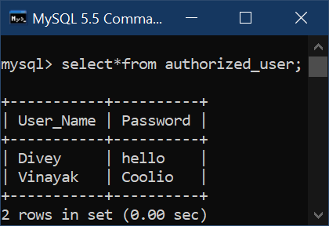

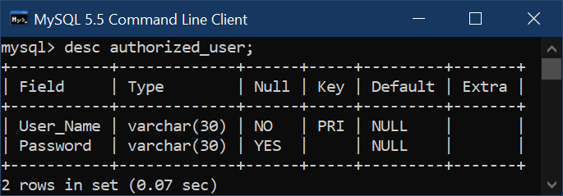

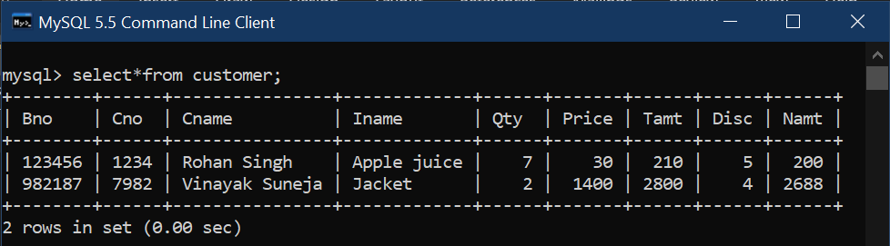Customer Table

